Fault-Tolerant Inkjet Gate Array for Application Specific Printed Electronic Circuits

M. Mashayekhi ^{(1,*)}, M. Llamas ⁽¹⁾, J. Pallares⁽²⁾, F. Vila⁽²⁾, L. Teres⁽²⁾, and J. Carrabina⁽¹⁾

(1) CAIAC - Department of Microelectronics and Electronic Systems Universitat Autònoma de Barcelona

(2) Institut de Microelectrònica de Barcelona, Centro Nacional de Microelectrònica, CSIC
e-mail: mohammad.mashayekhi@uab.cat

Application Specific Printed Electronic Circuits (ASPEC), are circuits designed and customized for a special application, (the equivalent term for ASIC in Organic Electronics). In this paper, we introduce Technology-Independent Fault-Tolerant Inkjet Gate Array (IGA) structure as a novel concept to allow ASPEC design in Organic Electronics. The main barrier for the wide adoption of printed electronic circuits is its poor yield. In order to overcome this issue, fault-tolerant concept is proposed as a strategy to allow achieving high yield on circuits out of foils with mid yield in Organic Thin Film Transistors (OTFTs) [1]. This solution is achieved by wiring only the Known Good OTFTs (KGO) which has been characterized and marked individually in the GA customization stage. So, depending on the number of KGOs and their position and the target function, each fabricated foil can have its own personalization. Furthermore, since there is a big variety of printed electronics process technologies, Paramiterizable-Cell (PCell) approach is used to scale the inkjet gate array regardless of the technology dimensions (design rules). In this methodology, IGA is divided into main pCells such as (Basic-Bulk-Cell (repetition of OTFTs), Wire-Cell, Inter-Connection Cell and PAD cells) and the design parameters of the pCells vary according to any target process restrictions [2].
IGA architecture is shown in Fig. 1 in which pseudo ratioed pMOS with three power rails (V_{DD}, GND, V_{SS}) is selected as the cell style in basic bulk cell, for a process with only p-channel transistors available. This structure has been designed and implemented for two different processes of CPI (Center for Process Innovation) and TUC (Technical University of Chemnitz) according to their Design Rules (DRC) restrictions and process yield. Fig. 2 is the IGA fabricated with TUC process.

[1] J. Carrabina, M. Mashayekhi, M. Llamas, C. M. Domingo, E. Ramon, A. Alcalde, J. Pallares, F. Vila, A. Conde, L. Teres, “INKJET GATE ARRAY: Novel Concept to implement electronic systems”, LOPEC2014, Munich, Germany
[2] TDK4PE, IGA Concept and related proposals, www.tdk4pe.eu
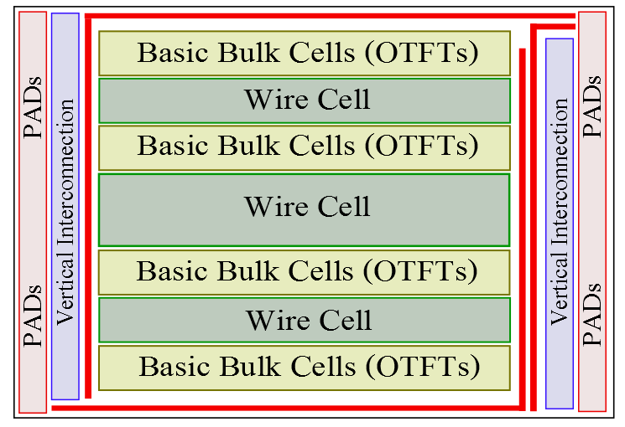
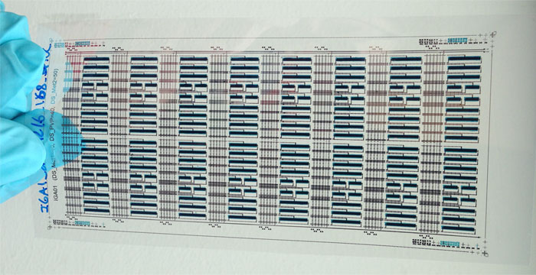

Fig. 1 Gate Array Architecture
Fig. 2 Inkjet Gate Array printed in TUC process

